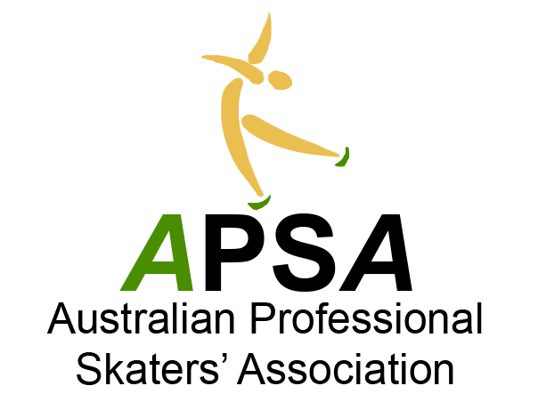
National Coaching
Accreditation Program
Coach Updating Log sheet
This form is designed to help you monitor and maintain your current level of accreditation with APSA by allowing you to log your updating activities for re-accreditation.
A copy of this form MUST be submitted with your re-accreditation application.
The list of approved activities can be found under the ‘Policy’ Tab

Name:.................................................................................................................... APSA accreditation number:...............................................

Email:.......................................................................................................
I acknowledge all activities listed to be true and correct. Signature:...............................................................Date:.......................................

State PSA: (please circle) NSWPSA QPSA SAPSA VPSA WAPSA

Level and discipline seeking re-accreditation for (list all disciplines and levels including harness):

………………………………………………………………………………………………………………………………………………………………………...

…………………………………………………………………………………………………………………………………………………………………………
Activities MUST be signed for or certificate of attainment / completion attached. Practical coaching hours can be signed by your rinks Skating Director, Skate School Co-ordinator or Rink Manager, Anyone found to have their points falsely verified will have their accreditation suspended until such time as the required points are completed and verified by APSA. If for any reason an activity can not be signed for please provide the reason.

PLEASE NOTE: APSA will be conducting random audits of update points submitted.
PLEASE SUBMIT BOTH PAGES.

DATE | ACTIVITY | ORGANISER | ROLE  E.g coach,presenter, specialist etc | VENUE | TOTAL HOURS / DAYS  IF APPLICABLE | VERIFICATION  (signature and name) | ADDITIONAL INFORMATION  (include if personal or practical coaching category)
E.g 2020/2021 | Annual coaching hours | If Lvl 0 it is the rink if not then leave blank | Coach | Macquarie Ice Rink | 50 (you only need to list the hrs to meet your requirements) | Signature | Practical coaching
E.g  09/06/20 | Hollins Trophy | SFSC | Coach | COIR | 2 days | PPC Attached | Practical coaching: Advanced Novice Ladies Competitor: Jade Doe
DATE | ACTIVITY | ORGANISER | ROLE  E.g coach,presenter, specialist etc | VENUE | TOTAL HOURS / DAYS  IF APPLICABLE | VERIFICATION  (signature and name) | ADDITIONAL INFORMATION  (include if personal or practical coaching category)

